

**Summer Industrial Training**

**II Semester, B. Tech**

**Log Book**

**Session 2020-21**

**Campus : PIET/PGI**

**Department of CSE/ AI/AI & DS**

**Name: ___________________ISHU KUMAR______________**

**Reg. No _PIET20CS080____________ Roll No:___20__________**

**Semester:__2ND__________ Year:______1_________**

**E-mail id:** [____ 2020pietcsishu80@poornima.](mailto:____%20%20%20%20%202020pietcsishu80@poornima.)org

**Contact No (WhatsApp): ....7004718739............................**

**Training Mentor/Tutor: nandani sharma / aisha Shahnawaz mam............................**

**Self Introduction (Min 100 Words)**

**My self Ishu kumar ,I am from BIHAR if I talk about my qualification I have completed my 10th from New Holi Ganges Publice School , khagaria after that I completed my 12th from Sri Chatanaya Vidiya Nikaten ,Visakhapatanam after that I have join Deheradun Doon Defence Accamedy in Deheradun at now I am curentelly**

**Computer Science Student form Poornima collage ,Jaipur**

**If I talk about my hobiye I like to travel different different places**

**My short term goal is to compleat my b.tech with good percentage and long tern gool is to serve the nation to join the defence sector.**

**If I talk about my weeknes I nevwr neglet to overcome to ower weekness**

# OVERVIEW OF INDUSTRIALTRAINING

Industrial Training program provides pre-professional work experience with specific assignments and responsibilities. An Industrial Training should be relevant to a student's personal career interests and academic courses of study, serving as a bridge between university and the world of work. Productive Industrial Trainings help students make informed decisions and improve their marketability after graduation.

Amidst of the ongoing circumstances of lockdown and restricted mobility, students are advised to pursue online summer Internships from their homes in Session 2020-21. Training & Placement Office, Poornima Group has recommended quality online-learning / training platforms, as well as the training areas for students to take up. Students must understand that this time is the most optimum time to upgrade one’s skill set and strengthen technical skills to establish a strong foundation for a prosperous career ahead. These trainings must be taken with utmost sincerity, and one must ensure the quality of training and its platform to make it more valuable and at par with industry standards.

1. **Selection of Course:** 
   1. Student is expected to take up any training / course / software from the recommended list of both online learning platform as well as the course.
   2. In case student wishes to opt for any other course apart from those mentioned in this list, he/she must take approval from the Department / TPO.
2. **Monitoring:** 
   1. To keep an account of the learning’s, student must maintain a log of training in provided format. Training monitoring guidelines shall be issued by respective departments.
   2. Student will be monitored by the respective Department.
3. **Duration of Training:** First Year : II Semester

|  |  |  |
| --- | --- | --- |
| **Mode of Training** | **Duration** | **Necessary Outcome Docs** |
| An online training / internship / Work-from-home program | 15 Days (16 August – 31 August 2021 ) | Letter of Confirmation +  Letter of Completion |
| Online certificate courses | 2 x 2 weeks OR 60 Hour (16 August – 31 August 2021) | Valid and verifiable certificate |

It is also advised that student take an additional personality development / communication enhancement program along with these technical courses to better prepare for the upcoming placement drives.

1. **Evaluation:** 
   1. The certificate of completion and duration of the undertaken course shall hold a strong weightage in training evaluation.
   2. The said online training will be equivalent upon the following components:
      1. Log book (i.e. regularity & punctuality)
      2. Course Completion Certificate (i.e. outcome)
      3. Submission of hard copy of Report (documentation submitted as per availability in Off line mode)
      4. Seminar presentation (presentation)
   3. Necessary and detailed instructions and dates shall be circulated by the respective department

**DETAILS OF THE TRAINING PROGRAM**

**Training 1 Detail:**

|  |  |  |  |
| --- | --- | --- | --- |
| **Sr.NO** | **Particulars** | | **Details** |
| **1** | **Name of Organization / Platform of Training** | | **Coursera** |
| **2** | **Technology Area / Course undertaken** | | **Python basic** |
| **3** | **Certificate awarding Organization** | | **UNIVERSITY OF MICHIGAN** |
| **4** | **Dates of Training / Certification course** | | **From :__12/8/2021_______ To : 30/8/2021__________** |
| **5** | **Duration in Hours / Weeks** | | **______ Hours OR _4____Weeks** |
| **6** | **Was it PAID / UNPAID or STIPEND based** | | **It was unpaid because I am sig in with collage id** |
| **7** | **Company Details in case of Internship** | **Website :** | |
| **Reporting Officer :** | |
| **Rep. Officer’s Contact No.:** | |
| **HR Name :** | |
| **HR Contact No. :** | |
| **Company Address:** | |

**Training 2 Details (If applicable)**

|  |  |  |  |
| --- | --- | --- | --- |
| **Sr.NO** | **Particulars** | | **Details** |
| **1** | **Name of Organization / Platform of Training** | | **udemy** |
| **2** | **Technology Area / Course undertaken** | | **Java** |
| **3** | **Certificate awarding Organization** | | **udemy** |
| **4** | **Dates of Training / Certification course** | | **From :__12/8/2021_______ To : __26/8/2021________** |
| **5** | **Duration in Hours / Weeks** | | **__45.5____ Hours OR _____Weeks** |
| **6** | **Was it PAID / UNPAID or STIPEND based** | | **paid** |
| **7** | **Company Details in case of Internship** | **Website :** | |
| **Reporting Officer :** | |
| **Rep. Officer’s Contact No.:** | |
| **HR Name :** | |
| **HR Contact No. :** | |
| **Company Address:** | |

**You may copy and paste the same table here for filling in details of any additional technical or non-technical training.**

**Weekly Log Report**

**Week 1 Dates: From:_12/8_______ To _18/8______**

|  |  |  |  |  |
| --- | --- | --- | --- | --- |
| **Sr.No.** | **Day and Date** | **Technology Working / studying on** | **Trg topics covered and Learning Outcomes** | **Time invested (in Hours)** |
|  | 12/8 | Coursera / udemy | basic | 1.5 hour |
|  | 13/8 | Coursera | basic | 1 hour |
|  | 14/8 | Coursera / udemy | Programming in python | 1 hour |
|  | 15/8 | Coursera / udemy | Programming in python | 1 hour |
|  | 16/8 | Coursera | Programming in python | 2 hour |
|  | 17/8 | Coursera | Programming in python | 2.5 hour |
|  | 18/8 | Coursera | Programming in python | 2.5 hour |

**Major Learning of the week:**

**________________________________________________________________________________________________________________________________________________________________________**

**Week 1 : Relevant screenshots / information that shall help**

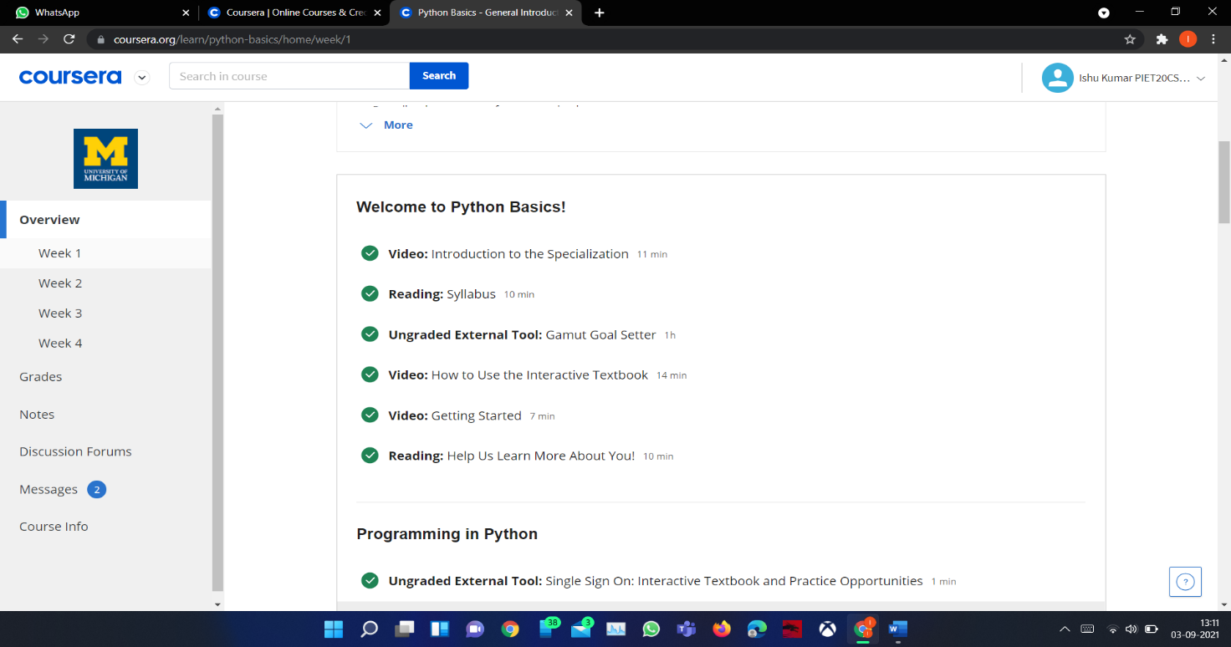

**Weekly Log Report**

**Week 2 Dates: From:__19/8______ To ___25/8____**

|  |  |  |  |  |
| --- | --- | --- | --- | --- |
| **Sr.No.** | **Day and Date** | **Technology Working / studying on** | **Trg topics covered and Learning Outcomes** | **Time invested (in Hours)** |
|  | 19/8 | Coursera | Programming in python | 2 hour |
|  | 20/8 | Coursera | Programming in python | 2 hour |
|  | 21/8 | Coursera | Programming in python | 2 hour |
|  | 22/8 | Coursera | Programming in python | 2 hour |
|  | 23/8 | Coursera | Programming in python | 2 hour |
|  | 24/8 | Coursera | Programming in python | 2 hour |
|  | 25/8 | Coursera | Programming in python | 2 hour |

**Major Learning of the week:**

**________________________________________________________________________________________________________________________________________________________________________**

**Week 2: Relevant screenshots / information that shall help in compiling report:**

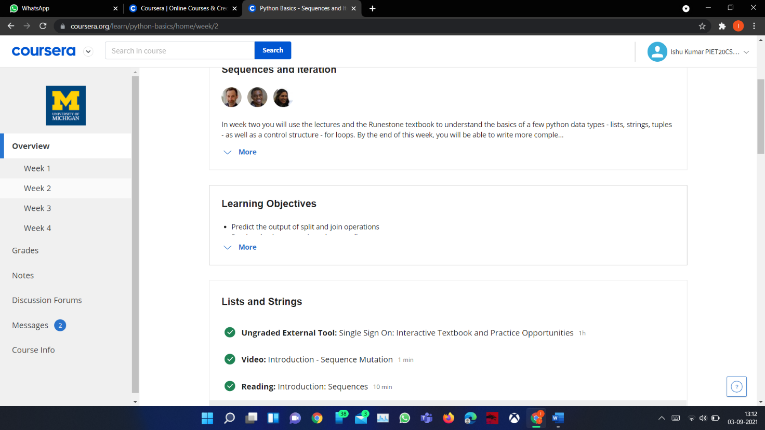

I am complete extra 2 more certificate

1. Soft slill
2. Autocad
3. Digital markating